SEC Form 4

FORM 4

Check this box if no longer subject to Section 16. Form 4 or Form 5 obligations may continue. See Instruction 1(b).

Check this box to indicate that a transaction was made pursuant to a contract, instruction or written plan for the purchase or sale of equity securities of the issuer that is intended to satisfy the affirmative defense conditions of Rule 10b5-1(c). See Instruction 10.

UNITED STATES SECURITIES AND EXCHANGE COMMISSION
Washington, D.C. 20549
Washington, D.C. 20549 |  | OMB APPROVAL
STATEMENT OF CHANGES IN BENEFICIAL OWNERSHIP
STATEMENT OF CHANGES IN BENEFICIAL OWNERSHIP |  | OMB Number: | 3235-0287
 |  | Estimated average burden
Filed pursuant to Section 16(a) of the Securities Exchange Act of 1934 |  | hours per response: | 0.5
or Section 30(h) of the Investment Company Act of 1940
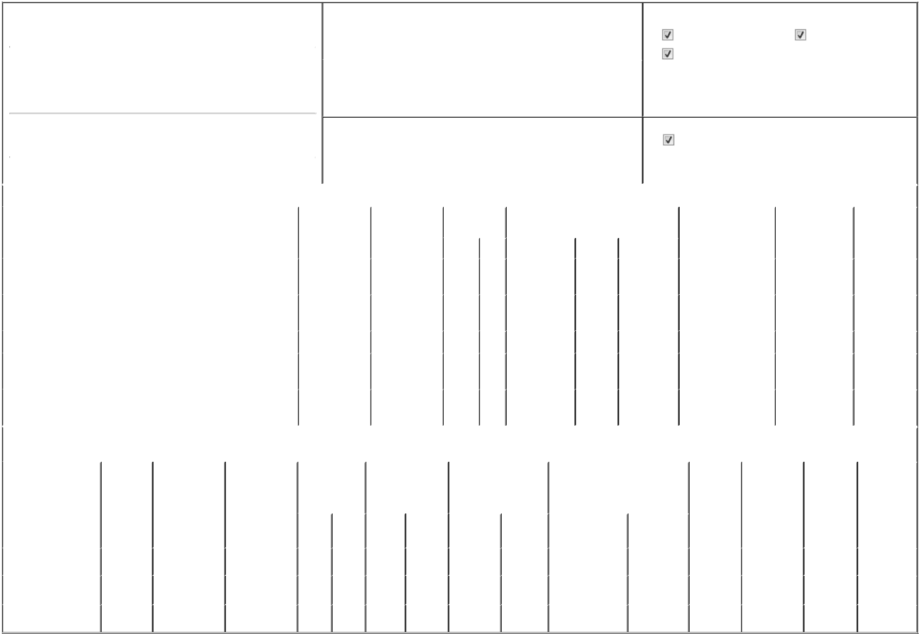

1. Name and Address of Reporting Person* |  |  |  | 2. |  |  | Issuer Name and Ticker or Trading Symbol
 | Houston Andrew |  |  |  |  | DROPBOX, INC. [ DBX ]
 | (Last) | (First) | (Middle)
 | (Last) | (First) | (Middle) | 3. |  |  | Date of Earliest Transaction (Month/Day/Year)
 | 1800 OWENS STREET
 |  |  |  | 08/14/2025

SUITE 200

- Relationship of Reporting Person(s) to Issuer (Check all applicable)

Director | 10% Owner
Officer (give title | Other (specify below)
below) | Other (specify below)

Chief Executive Officer

 | (Street) |  |  |  |  |  | 4. If Amendment, Date of Original Filed (Month/Day/Year) |  |  |  |  |  |  |  |  | 6. Individual or Joint/Group Filing (Check Applicable Line)
 |  | SAN FRANCISCO | CA | 94158 |  |  |  |  |  |  |  |  |  |  |  |  |  |  | Form filed by One Reporting Person
 |  |  |  |  |  |  |  |  |  |  |  |  |  |  |  |  |  |  | Form filed by More than One Reporting Person
 |  | (City) | (State) | (Zip)
 |  |  |  |  | Table I - Non-Derivative Securities Acquired, Disposed of, or Beneficially Owned
 | 1. Title of Security (Instr. 3) |  |  |  |  | 2. Transaction |  | 2A. Deemed |  |  | 3. Transaction |  | 4. Securities Acquired (A) or Disposed Of |  |  |  |  | 5. Amount of Securities |  |  | 6. Ownership |  | 7. Nature of
 |  |  |  |  |  | Date |  | Execution Date, |  |  | Code (Instr. 8) |  | (D) (Instr. 3, 4 and 5) |  |  |  |  | Beneficially Owned |  |  | Form: Direct (D) or |  | Indirect
 |  |  |  |  |  | (Month/Day/Year) |  | if any |  |  |  |  |  |  |  |  |  | Following Reported |  |  | Indirect (I) (Instr. 4) |  | Beneficial
 |  |  |  |  |  |  |  | (Month/Day/Year) |  |  | Code | V | Amount |  | (A) or (D) | Price |  | Transaction(s) (Instr. 3 |  |  |  |  | Ownership
 |  |  |  |  |  |  |  |  |  |  | Code | V | Amount |  | (A) or (D) |  |  | and 4) |  |  |  |  | (Instr. 4)
 | Class A Common Stock |  |  |  |  | 08/14/2025 |  |  |  |  | C |  | 92,000 |  | A | _{$0}(1) |  | 92,000 |  |  |  | I | See
 |  |  |  |  |  |  |  |  |  |  | C |  |  |  | A | _{$0}(1) |  |  |  |  |  | I | Footnote⁽²⁾
 | Class A Common Stock |  |  |  |  | 08/14/2025 |  |  |  |  | _{S}(3) |  | 92,000 |  | D | $27.8333⁽⁴⁾ |  | 0 |  |  |  | I | See
 |  |  |  |  |  |  |  |  |  |  | _{S}(3) |  |  |  | D | $27.8333⁽⁴⁾ |  |  |  |  |  | I | Footnote⁽²⁾
 | Class A Common Stock |  |  |  |  |  |  |  |  |  |  |  |  |  |  |  |  | 8,266,666⁽⁵⁾ |  |  |  | D
 | Class A Common Stock |  |  |  |  |  |  |  |  |  |  |  |  |  |  |  |  | 716,728 |  |  |  | I | See
 |  |  |  |  |  |  |  |  |  |  |  |  |  |  |  |  |  |  |  |  |  | I | Footnote⁽⁶⁾
 | Class A Common Stock |  |  |  |  |  |  |  |  |  |  |  |  |  |  |  |  | 444,444 |  |  |  | I | See
 |  |  |  |  |  |  |  |  |  |  |  |  |  |  |  |  |  |  |  |  |  | I | Footnote⁽⁷⁾
 |  |  |  |  | Table II - Derivative Securities Acquired, Disposed of, or Beneficially Owned
 |  |  |  |  |  | (e.g., puts, calls, warrants, options, convertible securities)
 | 1. Title of Derivative |  | 2. | 3. Transaction | 3A. Deemed | 4. Transaction |  | 5. Number of |  |  | 6. Date Exercisable and |  |  | 7. Title and Amount of Securities |  |  |  |  | 8. Price of | 9. Number of |  | 10. | 11. Nature of
 | Security (Instr. 3) |  | Conversion | Date | Execution Date, | Code (Instr. 8) |  | Derivative |  |  | Expiration Date |  |  | Underlying Derivative Security |  |  |  |  | Derivative | derivative |  | Ownership | Indirect
 |  |  | or Exercise | (Month/Day/Year) | if any |  |  | Securities Acquired |  |  | (Month/Day/Year) |  |  | (Instr. 3 and 4) |  |  |  |  | Security | Securities |  | Form: | Beneficial
 |  |  | Price of |  | (Month/Day/Year) |  |  | (A) or Disposed of |  |  |  |  |  |  |  |  |  |  | (Instr. 5) | Beneficially |  | Direct (D) or | Ownership
 |  |  | Derivative |  |  |  |  | (D) (Instr. 3, 4 and 5) |  |  |  |  |  |  |  |  |  |  |  | Owned |  | Indirect (I) | (Instr. 4)
 |  |  | Security |  |  |  |  |  |  |  |  |  |  |  |  |  |  |  |  | Following |  | (Instr. 4)
 |  |  |  |  |  |  |  |  |  |  |  |  |  |  |  | Amount or |  |  |  | Reported
 |  |  |  |  |  |  |  |  |  |  | Date |  | Expiration |  |  | Number of |  |  |  | Transaction(s)
 |  |  |  |  |  | Code V |  | (A) | (D) |  | Exercisable |  | Date | Title |  | Shares |  |  |  | (Instr. 4)
 | Class B Common Stock |  | (8) | 08/14/2025 |  | C |  |  | 92,000 |  |  | (8) | (8) |  | Class A Common | 92,000 |  | $0 |  | 67,375,629 |  | I | See foonote⁽²⁾
 |  |  | (8) | 08/14/2025 |  |  |  |  | 92,000 |  |  | (8) | (8) |  | Stock | 92,000
 | Class B Common Stock |  | (8) |  |  |  |  |  |  |  |  | (8) | (8) |  | Class A Common | 7,608,764 |  |  |  | 7,608,764 |  | I | See
 |  |  | (8) |  |  |  |  |  |  |  |  | (8) | (8) |  | Stock |  |  |  |  |  |  | I | Footnote⁽⁶⁾
 | Class B Common Stock |  | (8) |  |  |  |  |  |  |  |  | (8) | (8) |  | Class A Common | 500,500 |  |  |  | 500,500 |  | I | See foonote⁽⁹⁾
 |  |  | (8) |  |  |  |  |  |  |  |  | (8) | (8) |  | Stock | 500,500 |  |  |  |  |  | I

Explanation of Responses:

- 92,000 shares of Class B Common Stock were converted into 92,000 shares of Class A Common Stock at the election of the Reporting Person and had no expiration date.

- Shares held by the Andrew Houston Revocable Trust u/a/d 9/7/2011, for which Reporting Person serves as trustee.

- These shares were sold pursuant to a Rule 10b5-1 trading plan adopted by the Reporting Person on March 12, 2025.

- This transaction was executed in multiple trades at prices ranging from $27.71 to $28.11. The price reported above reflects the weighted average sale price. The Reporting Person hereby undertakes to provide upon request to the SEC staff, the issuer or a security holder of the issuer full information regarding the number of shares and prices at which the transaction was effected.

- These securities are restricted stock awards of Class A Common Stock. The restricted stock awards vest over a period of up to ten years following the closing of the Issuer's initial public offering of Class A Common Stock, or March 27, 2028, upon achievement of service-based, market-based, and liquidity event-related performance vesting conditions.

- Shares held by the Houston Remainder Trust u/a/d 12/30/2010, for which reporting Person serves as trustee.

- Shares held by The Erin Yu Houston Revocable Trust u/a/d 1/18/2024, for which the Reporting Person's spouse serves as trustee.

- The Issuer's Class B Common Stock is convertible into the Issuer's Class A Common Stock on a one-for-one basis at the Reporting Person's election and has no expiration date.

- Shares held by the Houston 2012 Irrevocable Children's Trust u/a/d 4/12/2012, for which Reporting Person serves as trustee.

Remarks:

 | /s/ Cara Angelmar, Attorney-in-Fact |  | 08/18/2025
 | ** Signature of Reporting Person |  |  | Date
Reminder: Report on a separate line for each class of securities beneficially owned directly or indirectly.
* If the form is filed by more than one reporting person, see Instruction 4 (b)(v).
** Intentional misstatements or omissions of facts constitute Federal Criminal Violations See 18 U.S.C. 1001 and 15 U.S.C. 78ff(a).
Note: File three copies of this Form, one of which must be manually signed. If space is insufficient, see Instruction 6 for procedure.
Persons who respond to the collection of information contained in this form are not required to respond unless the form displays a currently valid OMB Number.



